Content structure of the German guide

* Chapters are structured like a tutorial, from a process perspective start to end
* It takes into account that the mere functionalities of Banana are well described in the documentation so it won’t repeat what is in there
* The focus is on how to get done the whole accounting process as a user in Germany in a DATEV/ ELSTER environment
* Cooperation with a Steuerberater for End-of-year operations and data transfer is an option. Another is that users take care of the whole tax process
* It’s assumed that a typical user has some basic accounting knowledge

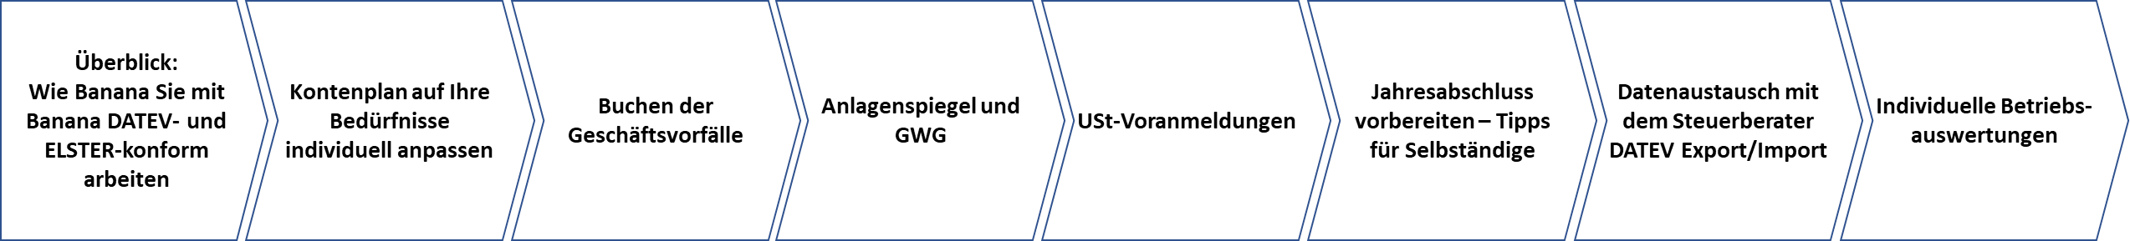

**Overview of how to best work with Banana as a German based user**

* Explain tutorial structure of this guide
* Many ways to work with Banana, form “free-style” to DATEV/ ELSTER compatible
* Most important Banana advantages as compared to traditional accounting software
* Advantages in using Banana AND cooperating with a Steuerberater
* Reference to structure accounting data in a DATEV compatible way and to transfer data to ELSTER

**Adapt Kontenpläne to personal needs**

* Available Kontenpläne on Banana
* Which tax relevant business are you corresponding to German legislation? What kind of Kontenplan do you need?
* Special SKR03Kontenpläne for cooperation with a Steuerberater (differences to other Kontenpläne provided in Banana)
* EÜR systematics, calculation of Betrieblicher Gewinn/ Steuerlicher Gewinn
* Adapt Kontenplan to personal needs from Master Kontenplan
* How to separate business/ private in a combined account plan in a DATEV/Steuerberater-compatible way

**Booking accounting transactions**

* The most important groups and accounts
* VAT codes, automatic accounts, and how they belong to certain expense and revenue accounts
* Import banking data, recommended cross checks and error avoidance
* A Collection of most important accounting records for German businesses, to be continued by request or user feedback, like booking of tax relevant particularities (eg Telefon, Bewirtung, Privatanteile, Cross-border transactions etc.)
* Useful references to external sources for further information on tax and DATEV conform booking of transaction cases
* Booking of private transactions, usage of private accounts

**Assets and Amortisations**

* Basic functionalities of the Banana Anlagen-Tabelle, Rough introduction to how it works and how to get started from the scratch
* Structure of the Anlagenspiegel-Table for EÜR and How to adapt it to personal need
* How to generate which amortization bookings and how to transfer the asset-table from year to year
* Some basics about German legislation concerning Amortisations (GWG, Pool- und Einzelabschreibung), typical amortization periods

**Umsatzsteuer-Voranmeldungen**

* Banana App? (or table?) to generate the Elster-Kennziffern, transfer to Elster manually or with interface?
* Reference to Banana standard VAT reporting (MwSt Zusammenfassung etc.)
* and more things depending on how exactly Banana will provide the Elster Kennziffern or interface (see Roadmap Elster)

**Preparing the annual financial statement and some tipps for entrepreneurs**

* How a DATEV conform tax report looks like, which data it provides, and how it is related to the forms
* How to generate with Banana the reports and print-outs that correspond to these tax reports
* Some tax relevant end-of-year bookings for KFZ-Nutzung, Arbeitszimmer, Vorsorgeaufwendungen etc.
* If available: How to generate the Elster Kennziffern, transfer data to Elster
* Reference to external sources for relevant tax legislation for entrepreneurs

**Data exchange with tax advisor**

* Datev export file and reimport file. Learning from experience and exchange
* Issues to clarify with the Steuerberater concerning account plan, bookings, amortisations etc.
* Avoiding errors in the Kontenplan concerning Datev- and Elster-relevant information when changing or adding accounts

**Individual business reports**

* Summary and reference to Banana functionalities Kunden/ Lieferanten, Profit/Cost-Centers, Segmente
* Budgeting and graphical representations
* Advantages to standard DATEV reports, possibilities
* Examples, use cases for different business types like Consulting, Engineering, Training, Production, Event-Management etc.